Tēnā tātou katoa, ngā mema o ANZASW
E ngā ringa raupā, e ngā pou o te hapori, ngā mihi mahana ki a koutou.
On the 11–12th of November, tangata whenua social workers gathered for our three-day Kia Rangatira Te Tū wānanga at Papakura Marae.
The feedback has been overwhelmingly positive:
- a deep appreciation for being in wānanga on the marae,
- inspiration from our experienced Māori social work practice leaders, reaffirming te ao Māori approaches to social work are valued, valid, and essential
- a strong sense of inclusivity and belonging for all who attended.
One of the whakatauākī/tongikura chosen for the wānanga was:
“Kotahi te kōhao o te ngira e kuhuna ai te miro mā, te miro pango, me te miro whero.” Through the eye of the needle pass the white, black, and red threads.
Fittingly, Te Ngira is also the name of the wharenui, and our time there was rich with kōrero, laughter, waiata, mana, warmth, and genuine connection, kotahitanga, unity in our diversity is our strength. Diverse experiences, iwi affiliations, and pathways, woven together through a shared kaupapa.
Thank you to everyone who attended and supported this kaupapa. Your call for more wānanga, more marae-based gatherings, and more spaces to uplift and strengthen tangata whenua practice has been heard loud and clear.
I’m delighted to share a couple of photos from the wānanga with you all.
Me whakakotahi tonu ā tātou miro hei raranga i te ara whakamua. Let’s continue weaving our threads together as we move forward.
ngā mihi, Lisa King
(Kaihautū)
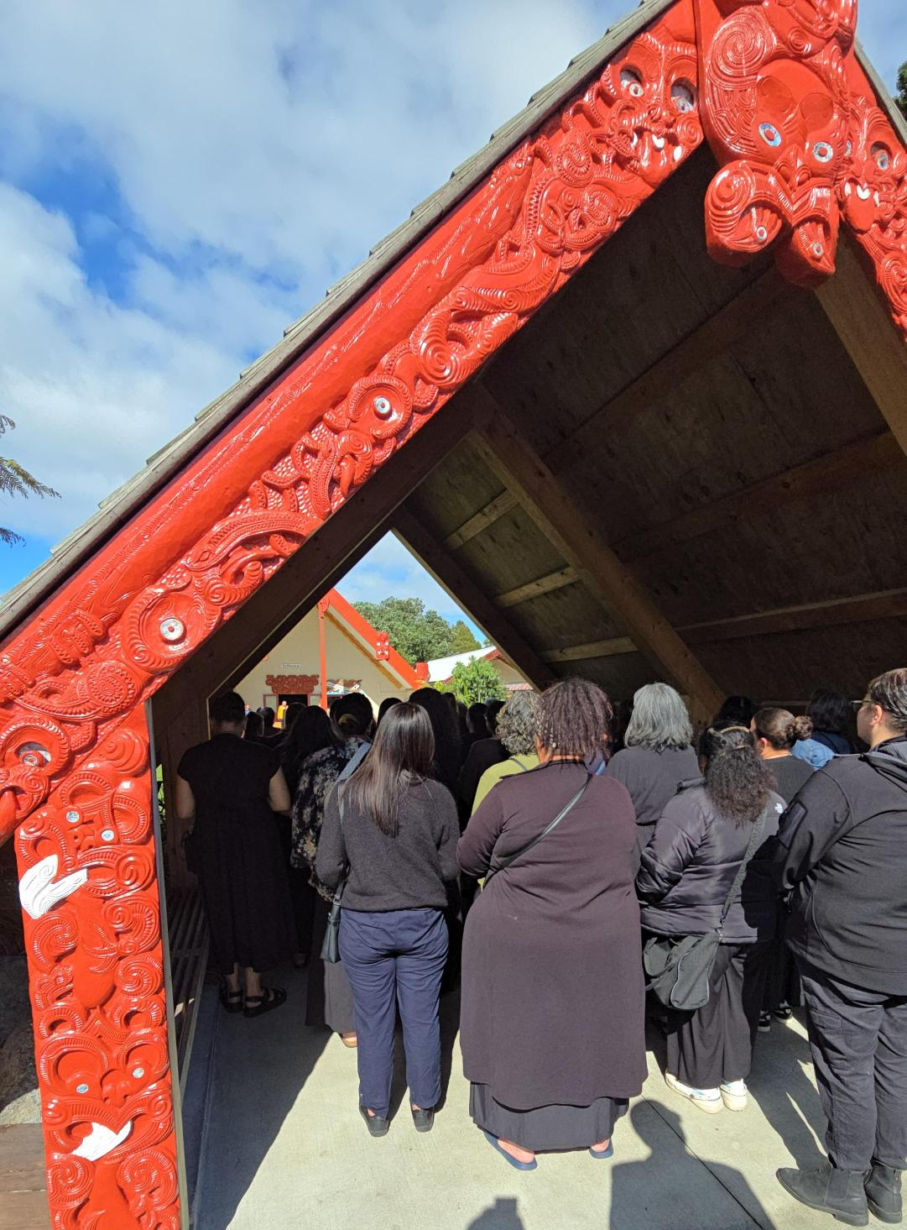
Being called onto the Papakura Marae 11/11/25

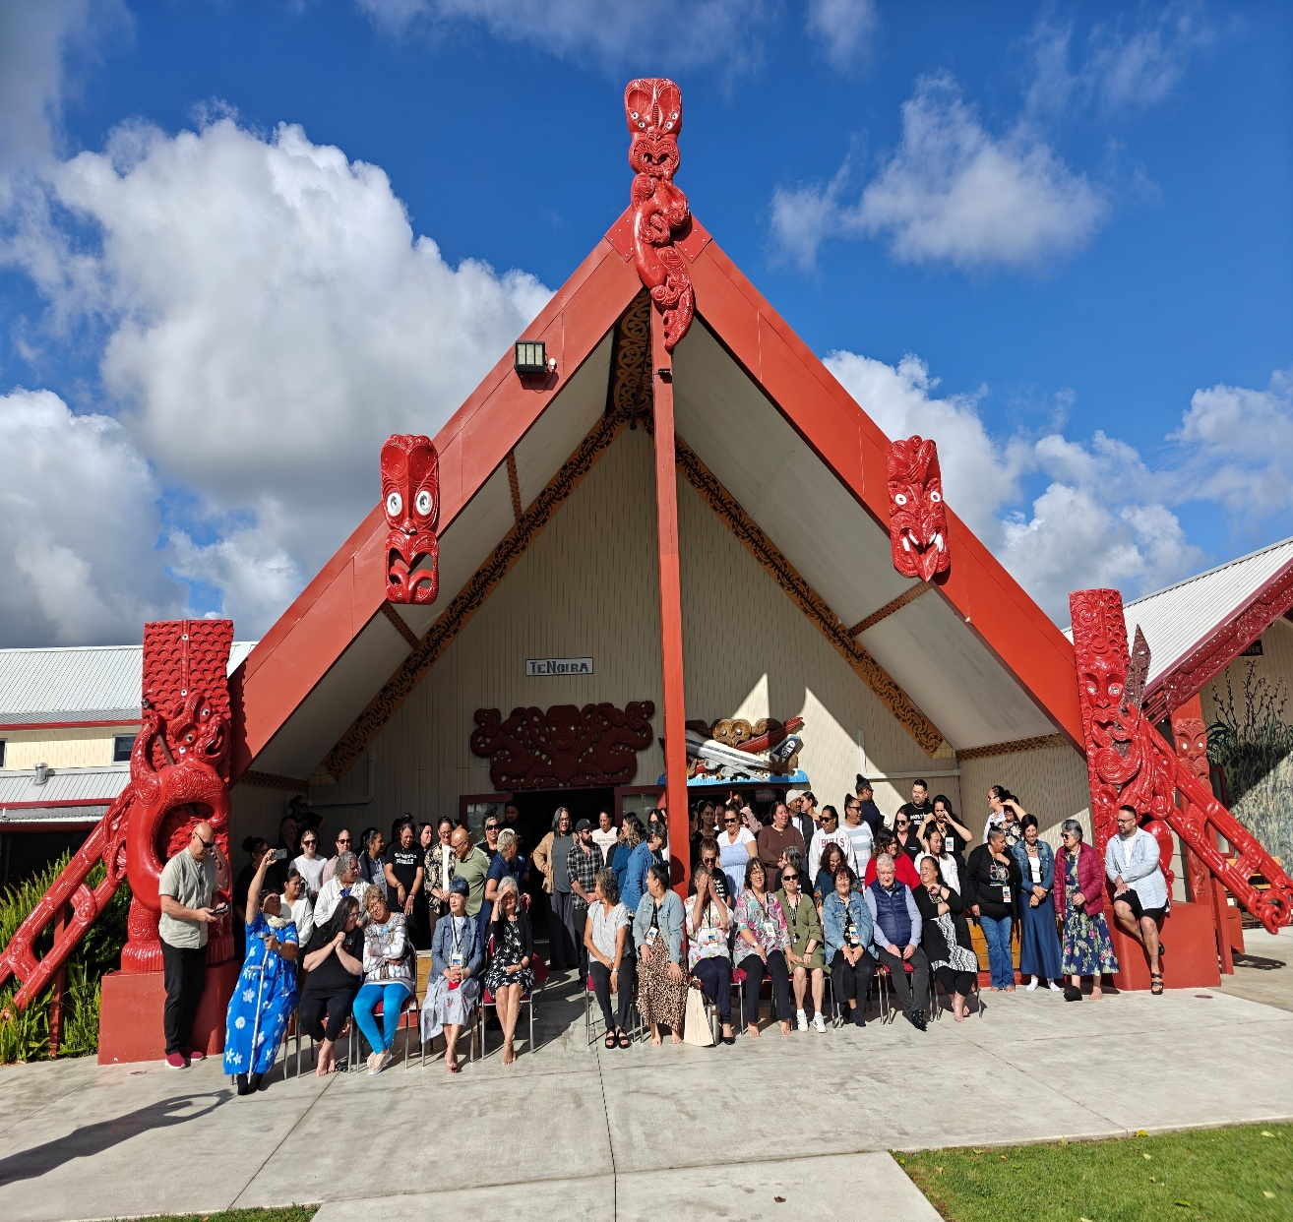
Kia Rangatira Te Tū Wānanga Papakura Marae 13th November 2025

